Directions for New Forest Village, Family Fun Day: Sunday, 13th July 2014

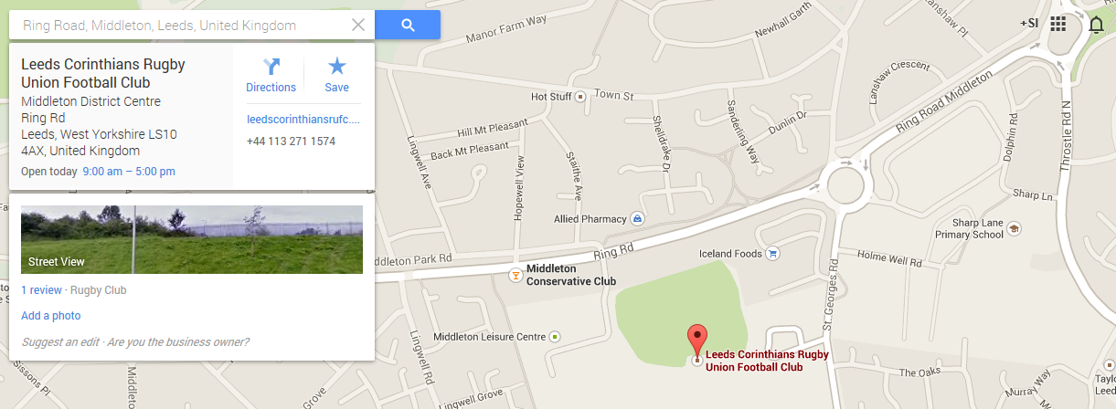

To find Leeds Corinthians, look for the sign: Leeds City Council Highways and Transportation (just off Middleton Ring Road). Turn into this entrance. Leeds Corinthians is first left when you get into the car park.
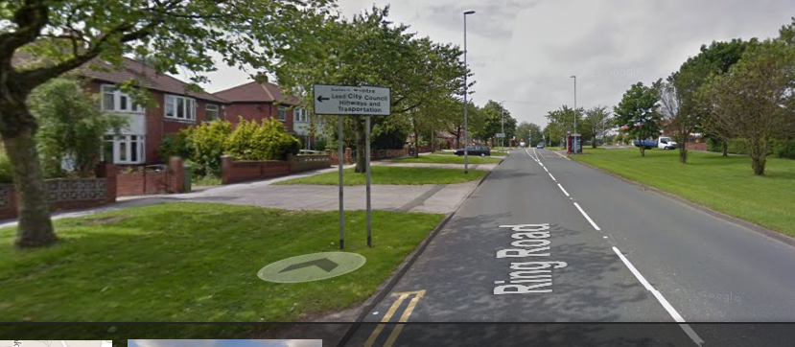
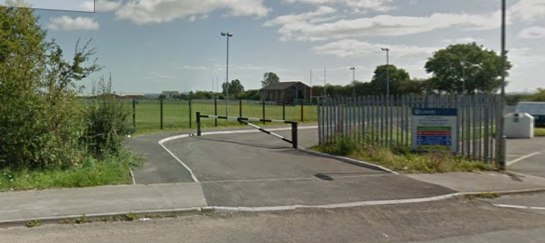
Rugby Club
Enter here

